**Experiment No.11**

**To Study The Cut Model Of Two Stroke Petrol Engine**

**11.1 Introduction:**

Any type of engine which drives heat energy from the combustion of fuel or any other source and converts this energy into mechanical work is known as a heat engine. Four stoke petrol engine is an internal combustion heat engine, in which the working cycle is completed into two stroke of the piston or one revolution of crankshaft.

The two stroke petrol engine contains two strokes:

1) Compression Stroke (Intake & Compression).

2) Power Stroke (Exhaust & Expansion).

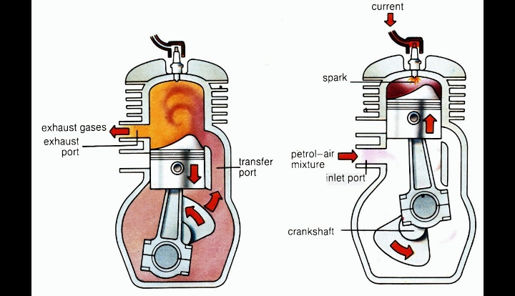

Figure 11.1Cut Section Of Four Stroke Petrol Engine

**11.1.1 ENGINE**

The motor which converts chemical energy into mechanical energy is called engine.

**11.1.2 PETROL ENGINE**

A petrol engine is an internal combustion engine with spark-ignition, designed to run on petrol

and same volatile fuels.

**11.2 WORKING OF FOUR STROKE PETROL ENGINE**

The two stroke petrol engine is an internal combustion engine in which the piston completes fourseparate strokes to complete one cycle turning crankshaft. The four strokes are as follows:

**9.2.1 COMPRESSION STROKE (Intake & Compression )**

In compression stroke, the two stroke petrol engine performs two functions. It intakes the mixture of petrol and air and it compressed the mixed fuel to the top dead-center (TDC). First of all the inlet port opens and the air fuel mixture enters the chamber,due to the fuel the piston started to move upwards. Piston compressed the mixture of air-fuel towards the spark plug.When the piston is at top dead center (TDC) the inlet port is opened and the exhaust port is closed. When the piston is at bottom dead center (BDC) the exhaust ports opened and the inlet port is closed. The spark plug burn the fuel compressed by the piston in the combustion chamber.

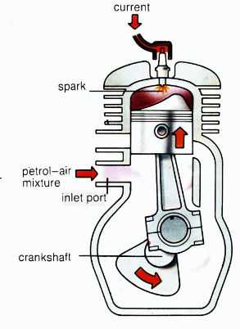

Figure11.2 Intake Stroke

**11.2.2 Power Stroke (Exhaust & Expansion):**

In power stroke, the two stroke petrol engine performs two functions. It exhausts the burned air and fuel mixture gas through the exhaust port and moves the piston towards the bottom dead center (BDC). The exhaust port opens and the burned air-fuel mixture removes from combustion chamber through exhaust port, due to the pressure of the coming fuel mixture from transfer port. Piston moves downwards due to the pressure of the burned fuel mixture. When the piston is at bottom dead center (BDC) the exhaust port is opened and the inlet port is closed. Similarly, when the piston is at top dead center (TDC) the inlet port is opened and the exhaust port is closed. The spark plug burn the fuel compressed by the piston in the combustion chamber and the burned fuel mixture is removed from the exhaust port.

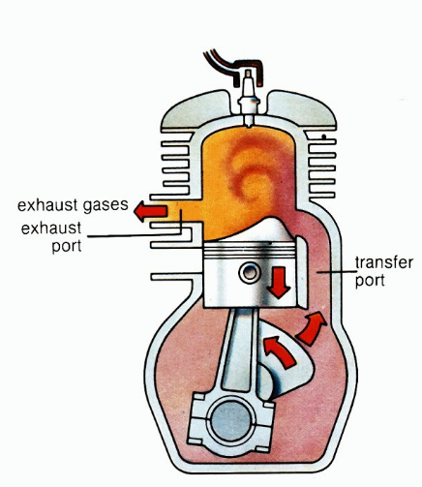

Figure: 11.3 power stroke( Exhaust& Expansion)

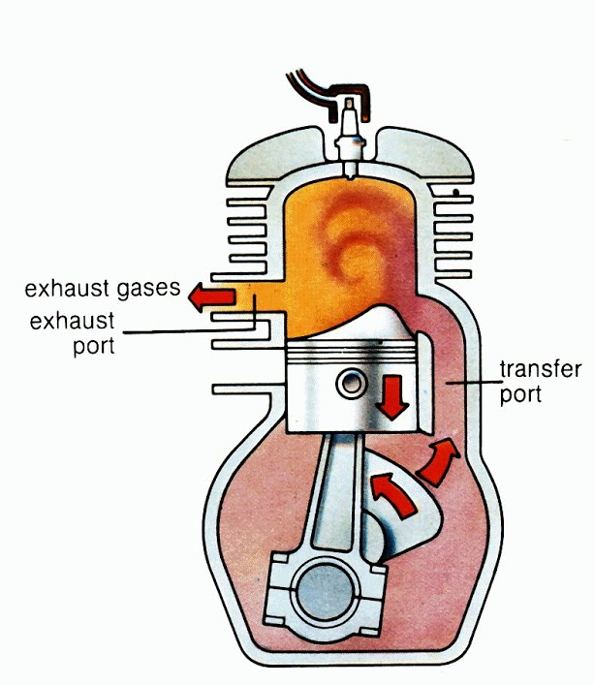

**9.2.3 POWER STROKE**

Power stroke is also known as combustion stroke. This is the start of the second revolution of the four stroke petrol engine. At this point the crankshaft has completed a full 360 degree revolution. As the fuel reaches the end of its combustion, the heat released by burning air-fuel mixture increases the pressure which causes the gas to push down the piston and create the power output.

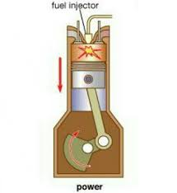

Figure9.4 Power Stroke

**9.2.4 EXHAUST STROKE**

Exhaust stroke is also known as outlet stroke. During the exhaust stroke the piston, once again, returns from bottom dead center (B.D.C) to top dead center (T.D.C). The exhaust valve is open when the piston reaches the bottom, which removes the burned air-fuel mixture gas through the exhaust valve when piston moves upward

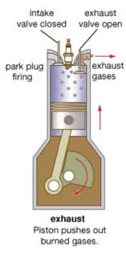

Figure9.5 Exhaust Stroke

**9.3** **PARTS OF FOUR STROKE PETROL ENGINE**

**9.3.1 CARBURETOR**

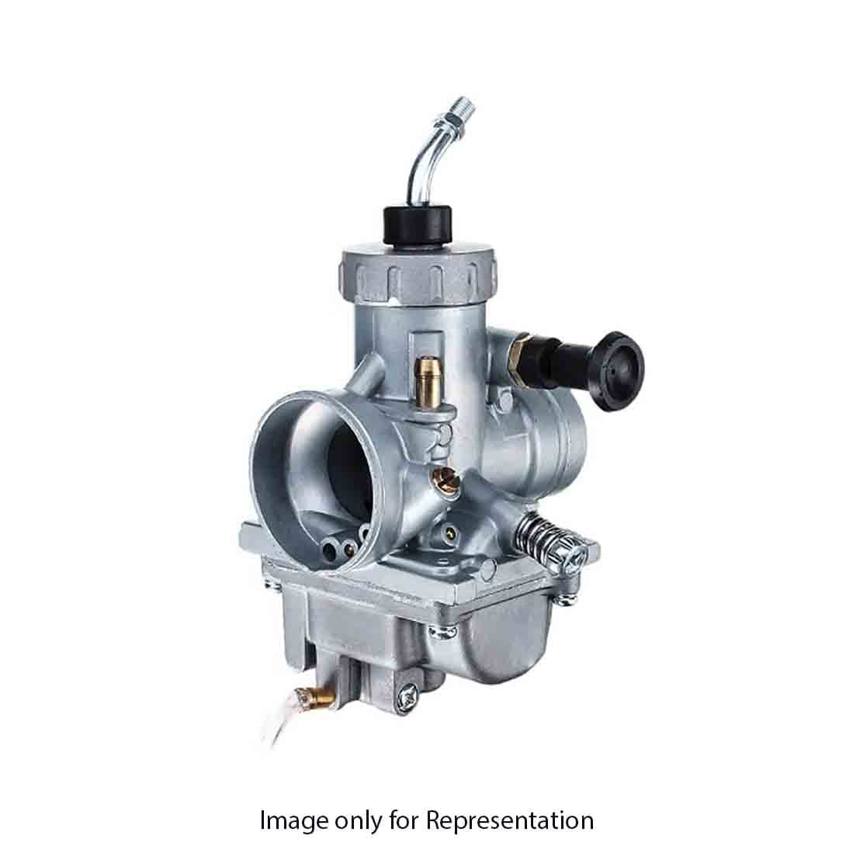 A carburetor or carburetor is a device that mixes air and fuel for internal combustion in four stroke petrol engine..

Figure9.6 Carburetor

**9.3.2 VALVE**

valves are used to control the amount of mixture of air and fuel in the cylinder. It controls the flow of air fuel mixture.

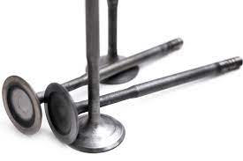

Figure 9.7 Valves

**9.3.3 SPARK PLUG**

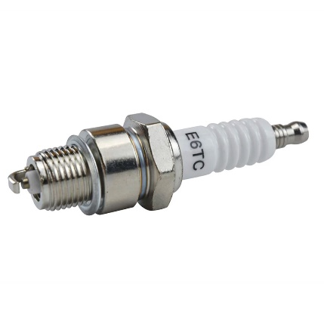 It is an electric plug used in four stroke petrol engine to provide an electric spark to the fuel for combustion.

Figure9.8 Spark Plug

**9.3.4 CYLINDER**

The cylinder is a space in which piston travels, the cylinder is the space through which the piston travels, propelled to the energy generated from the combustion of the air/fuel mixture in the combustion chamber. In an air-cooled engine, the walls of the cylinders are exposed to the airflow, to provide the primary method of cooling to the engine.

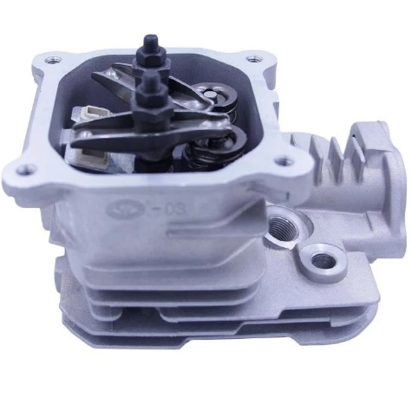

Figure 9.9 cylinder

**9.3.5 PISTON**

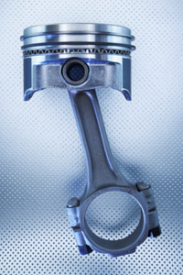 A piston is a disk which is used in four stroke petrol engine to moves upward and downward to derive motion.

Figure 9.10 Piston

**9.3.6 CONNECTING ROD**

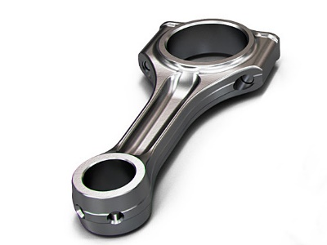 Connecting rod is used in four stroke petrol engine to connect piston and crankshaft.

Figure 9.11 Connecting Rod

**9.3.7 PISTON RINGS**

The piston rings act to carry heat away from the hot piston into the cooled cylinder wall/block of the engine. Heat energy flows from the piston groove into the piston ring and then into the cylinder wall, where it eventually will be transferred into the engine coolant.

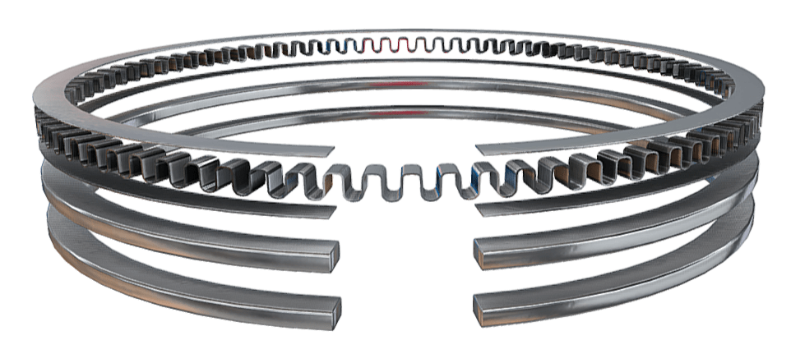

Figure 9.12 Piston Rings

**9.3.8 CRANK SHAFT**

Crankshaft is connected with a piston through connecting rod, which rotates when piston moves upward and downward.

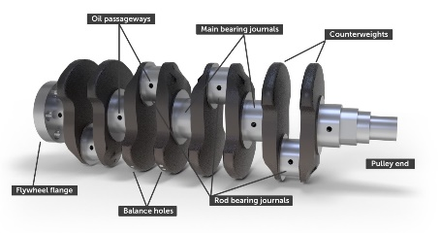

Figure9.13 Crank Shaft

**9.3.9 CAM SHAFT**

A camshaft on an internal combustion heat engine is a device that controls both the input of fuel and the expulsion of exhaust fumes. It consists of several radial cams, each displacingintake or exhaust valves.The head plugs the nozzle that allows fuel intake or exhaust flow and requires linear motion.

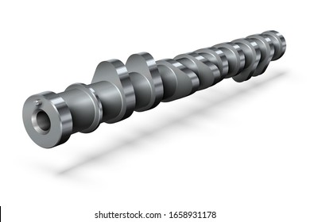

Figure9.14 Cam Shaft

**9.3.10 TOP DEAD CENTER (TDC)**

Top dead center is the maximum distance that a piston can cover upwards.

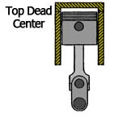

Figure9.15 (TDC)

**9.3.11 BOTTOM DEAD CENTER ( BDC)**

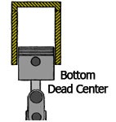 Bottom dead center is the minimum distance that a piston can cover downwards.

Figure9.16(BDC)